**System implementation, testing and validation report for maternal mortality rate prediction and advisory system.**

|  |  |
| --- | --- |
| Document No: |  |
| Prepared by: | KYANZI HASSAN MUSISI  WAMALA EDGAR WATSON  ASIIMWE BRENDA ANGEL  and TINDYEBWA ALLAN FORTUNATE |
| Date: | 20th-01-2022 |
| Version: | 3.0 |

Document Approval

|  |  |  |  |
| --- | --- | --- | --- |
| **Name** | **Role** | **Date** | **Signature** |
| Asiimwe Brenda Angel | Author |  |  |
| Tindyebwa Fortunate Allan | Author |  |  |
| Wamala Edgar Watson | Author |  |  |
| Kyanzi Hassan Musisi | Author |  |  |
| Dr. Moses Ntanda | Validation |  |  |
|  | Client |  |  |

**Table of Contents**

1.Introduction 1

1.2 Background 1

1.3 Scope of the project 2

1.4 Overview of the document 3

2. System Specifications 3

2.1 Version of requirements and Version Control 3

2.2 Inputs 3

2.3 Outputs 4

2.4 Functionality 5

2.4.1 Safety Requirements 5

2.4.2 Security Requirements 5

2.5 Limitations and safety 6

2.6 Default settings 6

2.7 Special requirements 6

2.8 Errors and alarms 6

3. Design output 7

3.1 Implementation (coding and compilation) 7

3.2 Documentation 9

4. Inspection and testing 10

4.1 Introduction 10

4.2 Test plan and performance 13

4.2.1 Test objectives 13

4.2.2 Scope and Relevancy of tests 13

4.2.3 Levels of tests 14

5. Installation and system acceptance test 15

5.1 Input files 15

5.2 Supplementary files 15

5.3 Installation qualification 16

6. Performance, servicing, maintenance, and phase out 18

6.1 Service and maintenance 18

6.1.1 Service and support concerning maintenance 18

6.2 Future updates 18

6.3 Requested modifications 18

7. Performance and Maintenance 20

8. USER MANUAL 22

8.1 System Overview 22

8.2 System Features 22

1. 2.0.1 The admin can add new mothers to the registration database 22

9. Reference Material 29

**List of Tables**

Table 1:Design Details 9

Table 2:Inspection plan and performance 12

Table 3:Checklist of the Installation and system acceptance test 16

Table 4.1: Installation Procedure Check 17

Table 5: Performance and maintenance details 21

**List of Figure**

Figure 1:Register pregnant mother 22

Figure 2:Mother details 23

Figure 3:solution by doctor 24

Figure 4:Problems and solutions 25

Figure 5:Output Example 26

Figure 6:Maternal mortality Prediction Dashboard 27

Figure 7:Generating future predictions with fbprophet timeseries model 28

# 1.Introduction

**Problem Description**

Maternal Mortality in Uganda is about 343 per 100,000 live births[1]. Maternal Mortality is death of women during pregnancy or child birth. Uganda wants to achieve the SDGS in particular goal 3 which is to reduce the Global maternity ratio to less than 70 per 100,000 live births and that’s the reason it is fighting tooth and nail to reduce maternal mortality. Among interventions to reduce maternal mortality is providing women access to quality maternal health care and maternal health information. So, we came up with a system that can provide reliable maternal health care information or advice to the women in Uganda more so those living in rural areas but have the basic phone that can send and receive messages, our system can also predict maternal mortality ratios and can also provide analytics of maternal deaths in Ugandan regions hence help policy makers decide where to fund more in order to curb this problem.

This report provides a view of how the design unfolded. We begin with an outline of the Maternal Mortality Rate Prediction and Advisory system functions. We then move into the software project plan and the requirements models from the previous report. Next, we cover architecture of the system and sub-systems. Included are class, activity, state, and sequence diagrams that show what our software is supposed to do and when it does it. Then we move into implementation with real screenshots of the running software. Finally, we introduce test cases and testing practices.

**Success Criteria**

Our ssystem will be successful if it can address each stakeholder’s concerns. It is secure, reliable, and above all usable. It is will also be a great success if we continue to meet the deadlines for deliverables. Ultimately, success will depend on how well our team succeeds during usability testing.

## Background

Each year on a global scale about 536,000 girls and women die from child birth and pregnancy-related causes Statistics also show that in every minute that ticks at least one girl or woman dies. The majority of maternal deaths occur in developing countries and half of these happening in Sub-Saharan Africa. Sub-Saharan African women have a higher risk of dying during child birth than other women elsewhere. For Teenage women between fifteen and 19, child birth is the leading cause of maternal mortality and these are about twenty million around the world.[2].Maternal mortality is caused by a number of complications in pregnancy or child birth. Many of these complications arise due to the pregnancy itself, and others happen when pregnancy has aggravated an existing disease. They are basically four main causes of maternal mortality which are severe bleeding more so bleeding in the first weeks when a woman had just given birth, Hypertensive disorders which is referred to as eclampsia which is a condition in which one or more convulsions occur in a pregnant woman suffering from high blood pressure, often followed by coma and posing a threat to the health of mother, Complications when women make unsafe abortions also lead to maternal mortality not forgetting Obstructed labour, hypertensive disorders in pregnancy (eclampsia) and obstructed labour. Other causes are indirect say malaria, anaemia and HIV.

Reducing maternal mortality can be a daunting task yet its causes are flagrantly the same over the last decade.[3] Most countries including Uganda have made progresss on increasing the availability of maternal healthcare but still many women in Uganda have no full access to this care. Uganda faces a number of obstacles in its bid to reduce maternal mortality say insufficient data that limits the ministry of health in implementing programmes most effectively, while cost and other access issues prevent women from using the available resources.

Cost of implementation, may not be the primary obstacle, the major obstacles include women not being able to get access to quality maternal health care and information. when they need it. Most regions in Uganda still face a crisis of health professionals equipped with necessary maternal health care skills and information Infrastructure say roads leading to available health centers are very poor for vulnerable pregnant women to use. Perhaps it’s for those reasons that we developed the Maternal Mortality Rate Prediction and Advisory system. Our goal is creating a system that can provide advice inform of sms messages in real time to women who face so many obstacles to get this information.

Many international health bodies agree that in order to combat maternal mortality, data collected must be accurate to ensure preventable maternal deaths are reduced. So, there has been so many efforts to collect and utilize maternal mortality data however, the challenge is failure to utilize this data fully to develop and implement recommendations and action points. MMRPAS (Maternal Mortality Rate Prediction and Advisory System) relies on the data collected in DHIS2 system about Maternal Mortality to make prediction then derive advice to mothers recorded in our database.[4]

## Scope of the project

It is our main objective is to create software that is easy to use, simple, and functions well and consistently. All we wanted was to create software that can be user friendly and this means any user can effortlessly learn and use it. Giving each user the appropriate level of access to the required components is also important for usability and security. Our major focus in this particular ssystem was to create a single point of system that can predict maternal mortality rates of the coming years and also provide advice to women using SMSs.

## Overview of the document

This document describes the implementation, testing and validation findings for the MMRPA system. It is divided into the following chapters;

Chapter 1: This chapters gives an introduction of this report

Chapter 2: Give information about system specifications.

Chapter 3: This is about design out puts

Chapter 4: This is about inspection and testing

Chapter 5: This shows inspection and system acceptance tests

Chapter 6: This elaborates performance, servicing, maintenance

Chapter 7: This has the conclusions and reactions

Appendix: Different appendices

Final Approval for use

# System Specifications

The section describes and specifies the system completely and is the basis for the validation process.

## Version of requirements and Version Control

Version 1.3 of the requirements specification was derived from Version 1.0(initial version) by an advisory module to the system. This change was made because it was relevant for our system to not only predict but also advise women seeking information about maternal health which is listed as an intervention by W.H.O to reduce maternal morbidity. This was added to version 1.1 of the MMRPA system.

We used GIT as our version control tool and git tags were used to distinguish between one version and another.

## Inputs

All inputs the MMRPA system are past values of the maternal mortality ratios in Uganda concatenated with other driving time series values and timestamp embeddings. If past deaths per region will be used to utilize them to condition the prediction too.

**Input 1: The maternal mortality data**

This data is downloaded from DHIS2 System, a ministry of health system[4].

**Input 2: Time Range for data visualization**

This is an input to the visualization feature which specifies the graphs to be displayed based on the date range input.

**Input 3: Message**

This is an input to the notification feature. it describes the content of the message that will be sent to the the women seeking advice.

**Input 4: Date of Reminder**

This is an input to the notification feature which sets the date of sending a notification to the women entailing the next antennal care date. The date set, must be from the present date and onwards.

**Input 5: Advisory data**

Consequently, providing advice to different users involves the system calling to a machine learning model which will then identify the data related to what the user requires. The result is then sent to the display the advice to the user.

## Outputs

**Output1: Prediction results**

This is an output of the prediction feature. It is generated by the predictions subsystem and sent to the MMRPAS by the help of an API. Prediction results include Maternal mortality rates and prediction is expressed as numbers.

**Output2: Graphs**

This is an output of the visualization feature, and it consists of the Bar graphs and Pie charts and other graphs that show the maternal mortality in a given region based on the time range set.

**Output 3: Reminder**

This is an output of the notification feature that notifies mothers about their next Antenatal care. This is sent periodically based on the set date in the database and their content is dynamically set by the doctor.

## Functionality

**R001** MMRPA system allows users to predict maternal mortality ratios of coming months or years.

The user shall input a data range which will be sent to the prediction subsystem by the API. The prediction results will be sent back to the MMRPA subsystem. The user shall be able to view the prediction results and then save them into the database.

**R002** MMRPA system shall provide graphical analysis of the prevalence of maternal mortality in different regions.

The user shall input the time range to view the rate maternal mortality within the set time range and this data will be displayed in graphical form using Bar Charts and Pie Charts and other graphs.

**R003** MMRPA system shall notify mothers registered about the next antennal care visit.

**R004** MMRPA system shall provide reply to issues sent by pregnant mothers.

### Safety Requirements

The System will provide a warning message for mothers to seek for further assistance.

### Security Requirements

1. The MMRPA system will ensure data integrity whereby user data and records will be protected from unauthorized modification of the data.
2. The MMRPA system will be protected from DDOS attacks to increase availability of the system to the right system users.
3. Data transferred between the device accessing the MMRPA and the cloud will be encrypted to ensure data confidentiality.

## Limitations and safety

1. The level of accuracy of the sms messages for advisory part is affected by a machine learning model which requires enough training to produce nearly accurate results.
2. The accuracy of the prediction depends on the fbprophet time series model developed.
3. Since the system is to be accessed online, the users won't be able to perform predictions and send notifications in case they are not connected to the internet.

## Default settings

By default, the mother has to be notified on the same day she is supposed to come for an antenatal care visit. However, this can be adjusted by the doctor based on the pregnant woman’s preference.

## Special requirements

1. The admin’s credentials such as the password were encrypted preventing anyone having access to the database such as the database administrator to view the doctor's password.
2. Access to maternal health data is limited to only the super administrators who worked on that particular patient.

## Errors and alarms

1. In case the API to the prediction subsystem is offline, a message is shown during prediction.
2. In case the date format is violated an error message is shown.
3. In case the connection to the database fails, an error message indicating Database Failure is displayed.

# Design output

## Implementation (coding and compilation)

1. **Anaconda:** This is an environment we used to create, train, and test the maternal mortality model. This platform offers high computing resources which are required during the training phase of the model.
2. **Visual studio code:** This was our main text editor in the development of the system.
3. **GitHub:** This version control system enabled us to keep track of our code and documents during the development.
4. **MySQL server:** This enabled us in creating and managing our database.
5. **Postman:** This was used in the testing of the API that connects to the prediction backend model.
6. **Django framework:** This was used in achieving a better well-organized code that is modular and easy to maintain.
7. **Balsamiq:** We used this tool to design the user interface of the MMRPA system.
8. **Microsoft Visio:** This tool was used for drawings such as context diagrams, use case diagrams, entity relationship diagrams.
9. **Web Browser:** Google Chrome and Mozilla Firefox were used to run and test the MMRPA system.
10. **Stationary:** Pens, ruler and Paper were used to come up with low fidelity user interfaces for MMRPA.
11. **GSM**: Sending and receiving messages

|  |  |  |
| --- | --- | --- |
| Documentation | | |
|  | | |
| *Topics* | **Design output** | |
| **Good programming practice**  *Efforts made to meet the recommendations for good programming practice...* | Source code is... | Source code contains... |
| **Windows programming**  *If implementing Windows applications... remove this row* | Comments: | |
| **Dynamic testing**  *Step-by-step testing made dynamically during the implementation...* | Comments: | |

Table 1:Design Details

# Inspection and testing

## Introduction

Inspection and testing of the Maternal Mortality Rate Prediction and Advisory System involved preparation and thorough checking of the different MMRPAS project documents such as the SRS and SDD. This was done by the project members as the reviewers.

The group members of the MMRPAS project went ahead to examine the MMRPAS application by executing the application and defects found, were documented in an issue log which were later fixed.

|  |  |  |  |  |  |  |  |  |
| --- | --- | --- | --- | --- | --- | --- | --- | --- |
|  | **Topics** |  |  | **3.3.1 Inspection plan and performance** |  |  | **Date / Initials** |  |
|  |  |  |  |  |  |
|  |  |  |  |  |  |  |  |  |
| **Design output** | | |  | Program coding structure and source code | | 14/12/2021 | |  |
|  |  |  |  | Evidence of good programming practice | |  | Performed By | |
|  |  |  |  |  |  |  |
|  |  |  |  | Design verification and documented reviews | |  | Wamala Edgar Watson | |
|  |  |  |  |  |  |  |
|  |  |  |  | Change-control reviews and reports | |  |  |  |
|  |  |  |  | **Comments:** | |  |  |  |
|  |  |  |  | We reviewed the code structure, the software | |  |  |  |
|  |  |  |  | Design documents, and the system | |  |  |  |
|  |  |  |  | requirements specification. | |  |  |  |
|  |  |  |  | Both code and documents were well organized | |  |  |  |
|  |  |  |  | and well formatted. | |  |  |  |
|  | | |  |  | |  | |  |
| **Documentation** | | |  | System documentation, flow charts, etc. | | 14/12/2021 | |  |
|  |  |  |  | Test results | |  | Performed by | |
|  |  |  |  |  |  |  |
|  |  |  |  | User manuals, On-line help, Notes, etc. | |  | Asiimwe Brenda Angel and Tindyebwa Fortunate Allan | |
|  |  |  |  |  |  |  |
|  |  |  |  | Contents of user manuals approved | |  |  | |
|  |  |  |  |  |  |  |  | |
|  |  |  |  | |  |  |  |  |
|  |  |  | 10 | |  |  |  |  |



|  |  |  |  |  |  |  |  |  |
| --- | --- | --- | --- | --- | --- | --- | --- | --- |
|  | **Topics** |  |  | **3.3.1 Inspection plan and performance** |  |  | **Date / Initials** |  |
|  |  |  |  |  |  |
|  |  |  |  |  |  |  |  |  |
| **Software development** | | |  | Data integrity | | 14/12/2021 | |  |
| **environment** | | |  | File storage | |  |  |  |
|  |  |  |  |  | Performed by | |
|  |  |  |  |  |  |  |
|  |  |  |  | Access rights | |  | Kyanzi Hassan Musisi | |
|  |  |  |  |  |  |  |
|  |  |  |  | Code protection | |  |  |  |
|  |  |  |  | Installation kit, replication and distribution | |  |  |  |
|  | | |  |  | |  | |  |
| **Result of inspection** | | |  | Inspection approved | | 20/01/2022 | |  |
|  |  |  |  |  |  |  | The inspection | |
|  |  |  |  |  |  |  | was approved by | |
|  |  |  |  |  |  |  | all the team | |
|  |  |  |  |  |  |  | members. | |
|  |  |  |  |  |  |  |  |  |



Table 2:Inspection plan and performance

## Test plan and performance

### Test objectives

1. To confirm that the system works as expected by the end-user. This test was performed together with a team of experienced developers.
2. To find out whether the Prediction model is able to predict maternal mortality.
3. To find out whether advice sent to users is accurate to a given percentage.
4. To find out whether the prediction data can be visualized in graphs basing on regions and time range. This was done by setting the time range and the MMRPAS system was able to display the graphs based on the set time range.
5. To find out whether all the requirements that were stated in the SRS were fully implemented. This was done by reviewing the SRS document to identify core requirements of the MMRPAS system which were later compared to the main functions the MMRPAS system provides to the end user.
6. To find out whether the system features i.e. Prediction feature, visualization feature, and Notification feature work together after integration. This was done by testing these features separately, and then we tested the system as a whole after integration.

### Scope and Relevancy of tests

1. Data that was used for testing the Prediction feature were different from the ones used for Training the Prediction feature.
2. The advice can only be dependable in case the level of accuracy is above 80%. Once the level of accuracy is below 80%, further tests or reviews are highly recommended.

### Levels of tests

**Module Test**

Modules that were tested included the Prediction module, the web module and the Advisory module

**Under the Prediction module**, some random samples of the maternal mortality data were obtained online with defined results were tested with the MMRPAS prediction model and 90% of the prediction results were able to match the actual maternal mortality rates in DHIS2 system.

We found out that the accuracy of the prediction depends on how trained the prediction model has been trained.

# Installation and system acceptance test

## Input files

The following files will be required in order to deploy both the Maternal Mortality Rate Prediction and Advisory client Application and the MMRPAS Model online.

1. **MMRPAS Client.zip**

This Zipped folder contains files for handling the client logic such as sending the request predict to the model, Visualization of maternal mortality and notifying mother about the next antenatal care visit.

1. **MMRPAS Backend.zip**

This Zipped file contains the backend logic which receives the request from the client through the API, performs the prediction process, and sends back the prediction results and advice to the client App or message.

**MMRPAS.h5**

This is a saved trained model which is used to predict maternal mortality.

## Supplementary files

1. **Readme file**

The readme file includes the operation instructions, file manifest, contact information for the programmers, known bugs, link to MMRPAS’s GitHub repository, and the link to the project blog.

1. **User manual**

The user manual includes instructions about how to use the MMRPAS system.

## Installation qualification

The following Steps ensure and document that each component is deployed correctly.

|  |  |  |  |  |  |  |
| --- | --- | --- | --- | --- | --- | --- |
|  | *Topics* |  |  | **Installation summary** | |  |
|  |  |  |  |
|  |  |  |  |  | |  |
| **Installation method** | | |  | Automatic - installation kit located on the installation media | | |
|  |  |  |  | Manual - Copy & Paste from the installation media | | |
|  |  |  |  | **Comments:** | | |
|  |  |  |  | Deployment is done by just unzipping the **MMRPAS Client.zip and** | | |
|  |  |  |  | **MMRPAS Back.zip**, and uploading **MMRPAS.h5** | | |
|  | | |  |  | | |
| **Installation media** | | |  | Diskette(s) | | |
|  |  |  |  | CD-ROM | | |
|  |  |  |  | Source disk folder (PC or network) | | |
|  |  |  |  | Download from the Internet | | |
|  |  |  |  | **Comments:** | | |
|  |  |  |  | All the files to be deployed are included in the folder. | | |
|  | | |  | |  | |
| **Installed files** | | | 1. | | PHP files | |
|  |  |  | 2. | | Blade files | |
|  |  |  | 3. | | Python files | |
|  |  |  | 4. | | Keras h5 file | |
|  |  |  |  |  |  |  |

Table 3:Checklist of the Installation and system acceptance test



|  |  |  |  |  |  |  |  |  |
| --- | --- | --- | --- | --- | --- | --- | --- | --- |
|  | **Topics** |  |  | **Installation procedure** |  |  | **Date / Initials** |  |
|  |  |  |  |  |  |
|  |  |  |  |  |  |  |  |  |
| **Authorization** | | |  | Person responsible: | | 14/12/2021 | |  |
|  |  |  |  | KYANZI HASSAN MUSISI | |  |  |  |
|  | | |  |  | |  | |  |
| **Installation test** | | |  | Tested and approved in a test environment | | 15/12/2021 | |  |
|  |  |  |  | Tested and approved in actual environment | |  |  |  |
|  |  |  |  | Completely tested according to test plan | |  |  |  |
|  |  |  |  | Partly tested (known extent of update) | |  |  |  |
|  |  |  |  | **Comments:** | |  |  |  |
|  |  |  |  | The installations were completely tested and | |  |  |  |
|  |  |  |  | approved in both test and actual environments | |  |  |  |
|  |  |  |  | according to the test plan. | |  |  |  |
|  |  |  |  |  |  |  |  |  |



Table 4.1: Installation Procedure Check

# Performance, servicing, maintenance, and phase out

## Service and maintenance

### Service and support concerning maintenance

The programmers of the MMRPA system shall provide the following Maintenance and Support Services.

1. Programmers shall assess all changes to the MMRPAS and ensure that the changes made are tested.
2. Programmers shall provide Support Services via the Call Centre, E-mail Support and Web-based Support.
3. Programmers shall periodically deploy releases of the MMRPAS online.
4. Programmers shall monitor the operation of the MMRPAS and identify potential issues.
5. Programmers shall apply continuous efforts and resources to resolve any defect identified in the MMRPAS system.

## Future updates

1. Except in cases of emergency, Programmers shall notify the end users at least two days prior to activating each Update.
2. Version Control such as git shall be used to track and audit modifications to the MMRPAS components over time, and to facilitate the restoration of MMRPAS to prior development stages.

## Requested modifications

1. End users requesting for system modifications shall be required to fill and submit the change request form.
2. The requested change shall be analysed by the programmers of MMRPAS
3. Impact analysis shall be performed. The programmers shall assess the impact of the requested change to the MMRPAS system.
4. The programmers will decide to approve, reject, or put the requested change on hold.
5. If the requested change is approved, the programmers shall implement the change and update the system.

# Performance and Maintenance

The maximum time required for advice in form of sms reply is 5 seconds.

The accuracy of the trained prediction model of the MMRPAS system will be improved through continuous training of the MMRPAS model with more new maternal mortality obtained from a trusted source.

Online user manuals and hard copy manuals shall be provided to guide the intended users on how to use the MMRPAS system. Online user manuals will be immediately updated in case of a new feature or change to the MMRPAS system.

The MMRPAS system will be upgraded based on the changes requested or suggested by the intended users and the build versions will be managed using version control systems such as git.

|  |  |  |  |  |  |  |  |  |
| --- | --- | --- | --- | --- | --- | --- | --- | --- |
|  | **Topics** |  |  | **Performance and maintenance** |  |  | **Date / Initials** |  |
|  |  |  |  |  |  |
|  |  |  |  |  |  |  |  |  |
| **Problem / solution** | | |  | We detected that when a user enters so many words in their message, it’s difficult for the system to return a proper reply. | | 01/1/2022 | |  |
|  |  |  |  |  | |  |  |  |
|  |  |  |  |  | |  |  |  |
|  |  |  |  |  | |  |  |  |
|  |  |  |  |  | |  |  |  |
|  | | |  |  | |  |  |  |
| **Functional maintenance** | | |  | In case of any change in the functionality of | |  |  |  |
|  |  |  |  | MMRPAS system, the registered users shall be | |  |  |  |
|  |  |  |  | notified 2 days before the upgrade. | |  |  |  |
|  | | |  |  | |  |  |  |
| **Functional expansion** | | |  | The following suggestions are critical for the | |  |  |  |
| **and performance** | | |  | better performance of MMRPAS system. | |  |  |  |
| **improvement** | | |  | 1. [*Caching*](https://www.dnsstuff.com/web-application-performance#caching) | |  |  |  |
|  |  |  |  | 2. Optimizing the mammogram images. | |  |  |  |
|  |  |  |  | 3. Using Logs to monitor the | |  |  |  |
|  |  |  |  | performance of the system. | |  |  |  |
|  |  |  |  |  |  |  |  |  |
|  |  |  |  |  |  |  |  |  |

Table 5: Performance and maintenance details

**APPENDIX A:**

# USER MANUAL

## System Overview

The maternal mortality rate prediction allows users to make prediction, analyze data, send sms with their issues and get a reply is seconds.

## System Features

1. 2.0.1 The admin can add new mothers to the registration database

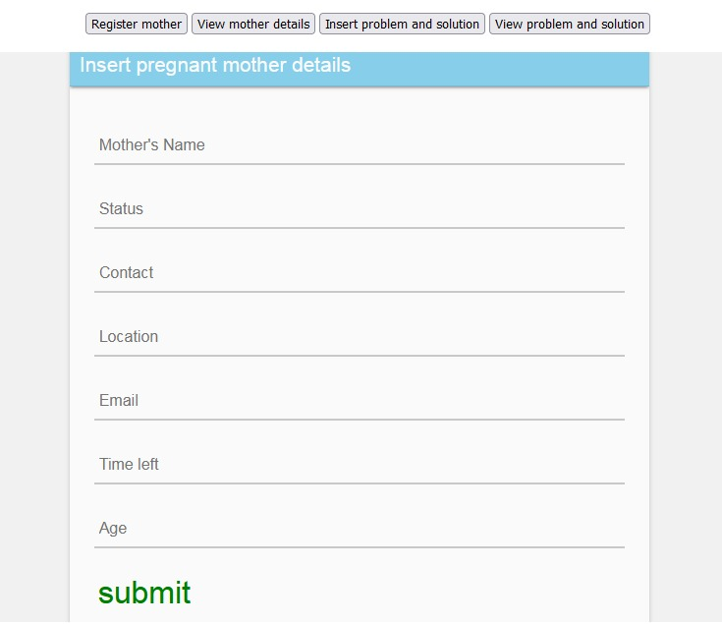

Figure 1:Register pregnant mother

On the same window, the admin can view mother details, insert problem and insert solution from a doctor, he/she can also view different problems and solutions.

**2.0.2 View Mother details**

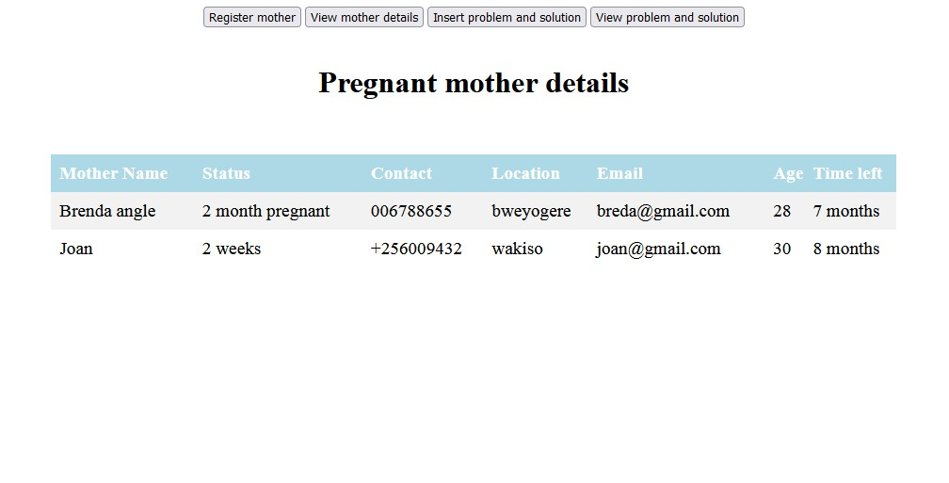

Figure 2:Mother details

**2.0.3 Doctor interface**

A doctor can add a problem and its solution

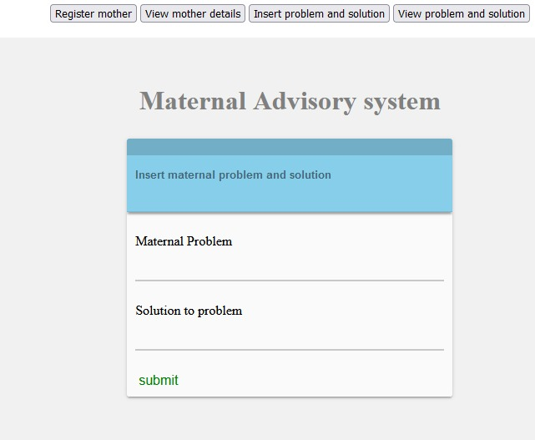

Figure 3:solution by doctor

**2.04 Doctor’s responses**

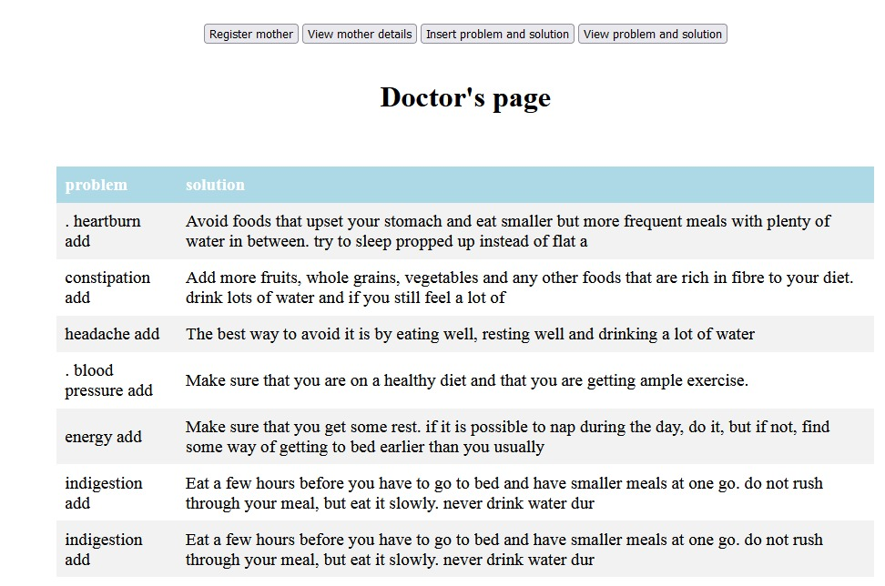

Figure 4:Problems and solutions

**2.0.5 Any person can send a message to our number with their question to our system**

When someone types their question and send to our number, they expect a response in the shortest time.



Figure 5:Output Example

**2.0.6 A user can predict and analyze using this system**

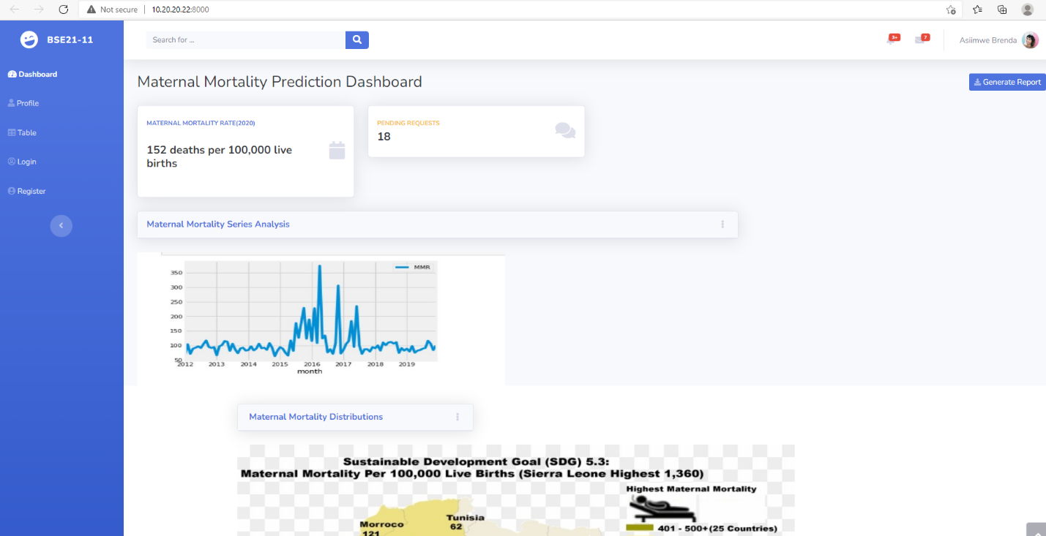

Figure 6:Maternal mortality Prediction Dashboard

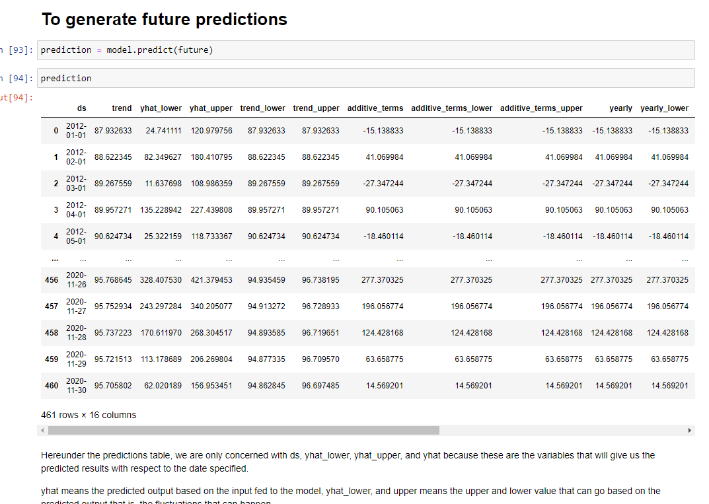

Figure 7:Generating future predictions with fbprophet timeseries model

# Reference Material

[1] “Maternal Mortality.” https://www.who.int/data/gho/indicator-metadata-registry/imr-details/4622#:~:text=Definition%3A,and site of the pregnancy.

[2] sdsn, “Indicators and a Monitoring Framework Launching a data revolution for the Sustainable Development Goals.” https://indicators.report/indicators/i-17/.

[3] MITRE, “No Title,” 2021. https://www.mitre.org/publications/project-stories/can-data-modeling-and-analytics-help-reduce-pregnancy-related-deaths.

[4] A. Panel, “Maternal Health: Investing in the lifeline of healthy societies and economies,” *Policy Brief. Sept.*, no. September, 2010.

[5] WHO, “Maternal mortality Evidance brief,” *Matern. Mortal.*, no. 1, 2017.

[6] M. of Health, “No Title.” https://hmis.health.go.ug/dhis-web-commons/security/login.action (accessed Aug. 20, 2021).

|  |  |  |
| --- | --- | --- |
| **Final approval for use** | | |
| Identification: | |  |
| Responsible for validation: | |  |
| Remarks: | | |
| Date: | Signature: | |
|  |  |  |